**Driving Towards Sustainability: Renewable Energy, Electric Vehicles, and Carbon Footprint Trends**

By

Pavan Teja Gupta Allenki

U44608698

**Introduction**

The world is at a critical juncture in its efforts to combat climate change, with transportation being one of the largest contributors to greenhouse gas emissions. Electric vehicles (EVs) have emerged as a promising solution to reduce CO2 emissions from the transportation sector. The United States, as one of the largest automotive markets in the world, plays a crucial role in the adoption and growth of EVs. Understanding the dynamics of EV adoption and its impact on CO2 emissions is vital for policymakers, manufacturers, and consumers alike.

In recent years, the USA has witnessed a significant increase in the adoption of electric vehicles. Factors such as government incentives, technological advancements, and growing environmental awareness have contributed to this trend. The availability of charging infrastructure is a key determinant in the widespread adoption of EVs. Analyzing the distribution and accessibility of charging stations across the country can provide valuable insights into the challenges and opportunities for EV adoption.

CO2 emissions from the transportation sector are a major contributor to global greenhouse gas emissions. The shift towards electric vehicles has the potential to significantly reduce these emissions. By analyzing global CO2 emissions data and comparing it with the adoption rate of EVs, we can assess the effectiveness of EVs in mitigating climate change. Understanding the impact of EVs on CO2 emissions can inform future policies and strategies aimed at promoting sustainable transportation.

**The ambitiousness of the project**

This project aims to utilize data visualization techniques to present a comprehensive analysis of electric vehicle adoption and its impact on CO2 emissions. By examining the USA's electric vehicle landscape and charging infrastructure alongside global CO2 emissions data, the project seeks to highlight the potential of EVs in reducing greenhouse gas emissions and promoting sustainable transportation practices. Through compelling visualizations, the project aims to inform and educate stakeholders about the benefits and challenges of EV adoption, ultimately contributing to a more sustainable future.

**Research Questions**

The research questions of this project are:

1. Which state leads in EV, Hydrogen, and Ethanol Fuel Stations in USA?
2. What is the share of EV vehicles in USA & which type of vehicle leads?
3. What is the percentage increase in sales of electric vehicles in USA according to the data set & CAGR?
4. Which state leads in number of Electric Vehicles, Hybrid, Plug-in Hybrid vehicles?
5. Is there is any correlation between Sales of EV & CO2 Emissions?
6. How many numbers of EV models are present in market & where does Tesla stand?
7. Which state has highest number of Laws & Incentives to the alternative source of vehicles like EV & Hydrogen?
8. What are the total CO2 emissions of USA in 2021?

**Methodology**

**1) Alternative Fuels Data Center – US Dept of Energy**

**Source:** [**Alternative Fuels Data Center - US Dept of Energy**](https://afdc.energy.gov/data)

The Alternative Fuels Data Center (AFDC), launched by the U.S. Department of Energy in 1991, offers a wide array of information and tools on alternative and renewable fuels, advanced vehicles, fuel-saving strategies, and emerging transportation technologies. Originally created as a repository for alternative fuel vehicle performance data, the AFDC has since expanded into a dynamic online hub, providing interactive tools, calculators, and mapping applications to aid in the deployment of these fuels, vehicles, and strategies. Today, the AFDC serves as an indispensable resource for transportation decision-makers, offering the latest data, publications, case studies, and information to help businesses and communities make informed choices that reduce emissions, cut costs, and improve efficiency in transportation.

**2) USA CO2 Emissions**

**Source:** [**CO2 Emissions USA**](https://www.eia.gov/environment/emissions/state/)

The U.S. Energy Information Administration (EIA) collects, analyzes, and disseminates independent and impartial energy information to promote sound policymaking, efficient markets, and public understanding of energy and its interaction with the economy and the environment.

**3) World Wide CO2 Emissions:**   
**Source:** [**World Wide CO2 Emissions**](https://www.bp.com/en/global/corporate/energy-economics.html)

The Statistical Review analyses data on world energy markets from the prior year. It has been providing timely, comprehensive and objective data to the energy community since 1952.

**Analysis**

**1) Map View of All Fuel Stations:**

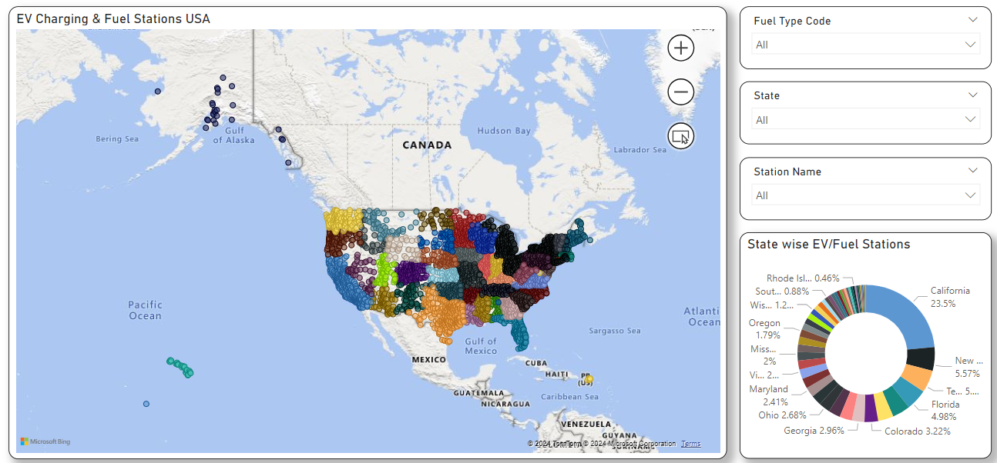

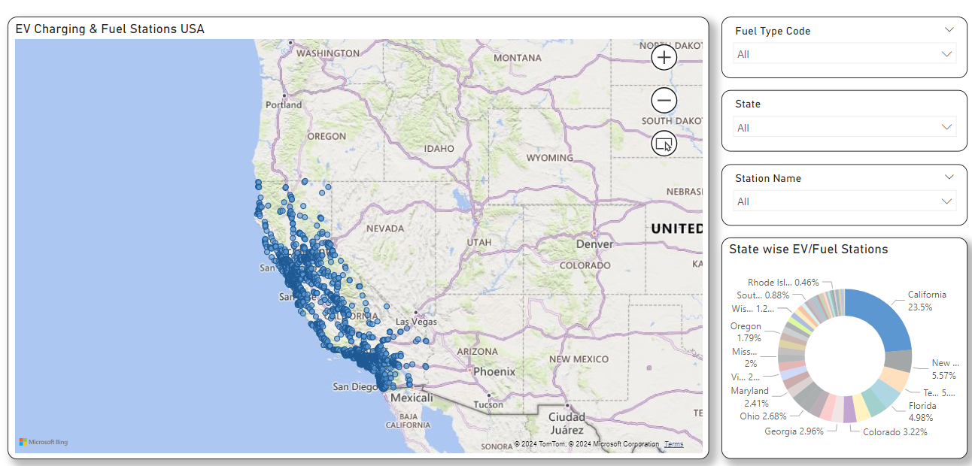

From the above visualizations we can see the Fuel Stations across USA with their Latitude & Longitude, State Name, Fuel Station Name. we can even Filter the Map based on State, Station Name & Fuel Type Code – BD, CNG, E85, ELEC, HY, LNG, LPG. California has the largest share in EV Charging Stations of 23.5% with 16532 stations.

**2) Vehicle Sales by Type:**   
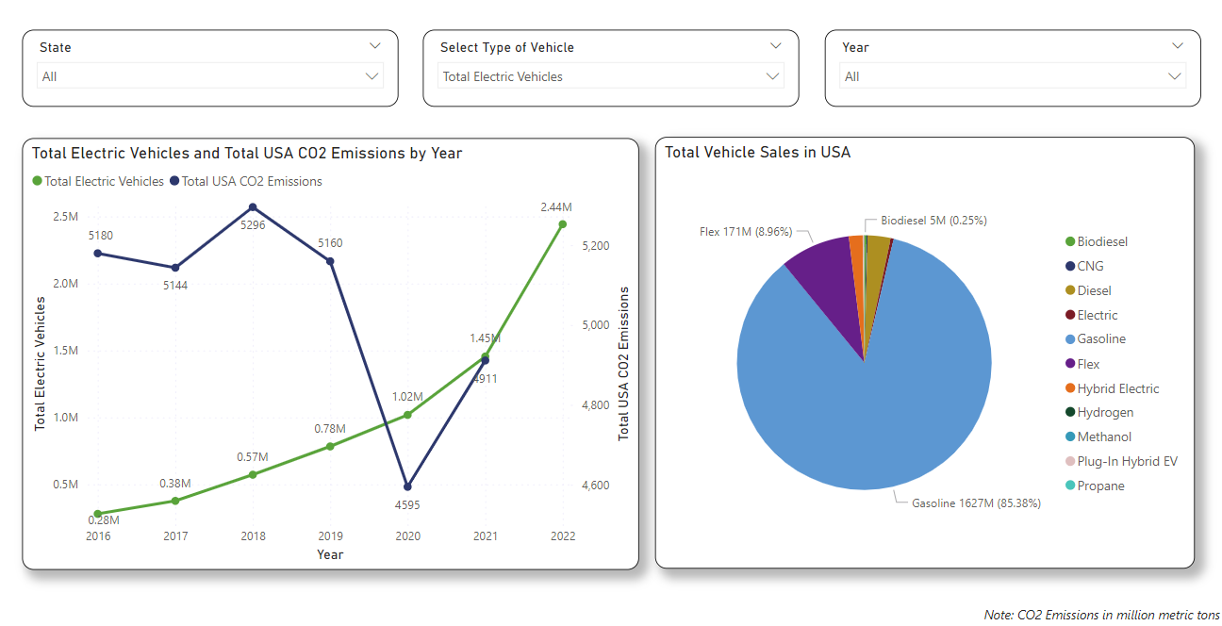

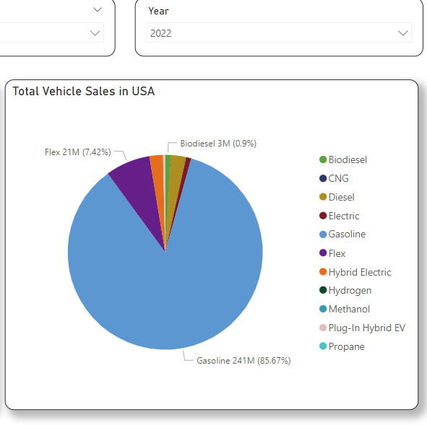

From the above figure we can see the relation between number of Electric Vehicles Vs CO2 Emissions & also the share of total vehicles based on fuel type. The sales of Electric Vehicles are increasing from the year 2016 with 0.28 million to 2.44 million in the year 2022. The levels of Co2 Emissions have been decreased from 2019 to 2020 due to combined effect of energy transition & covid 19 pandemic. In the year 2022 Gasoline occupies 85.67% of sales where as Electric Vehicles is only 0.87%. The share of the sales are as follows: Gasoline, Flex, Diesel, Hybrid Electric, Electric & others.

3) **Vehicle Sales by State:**

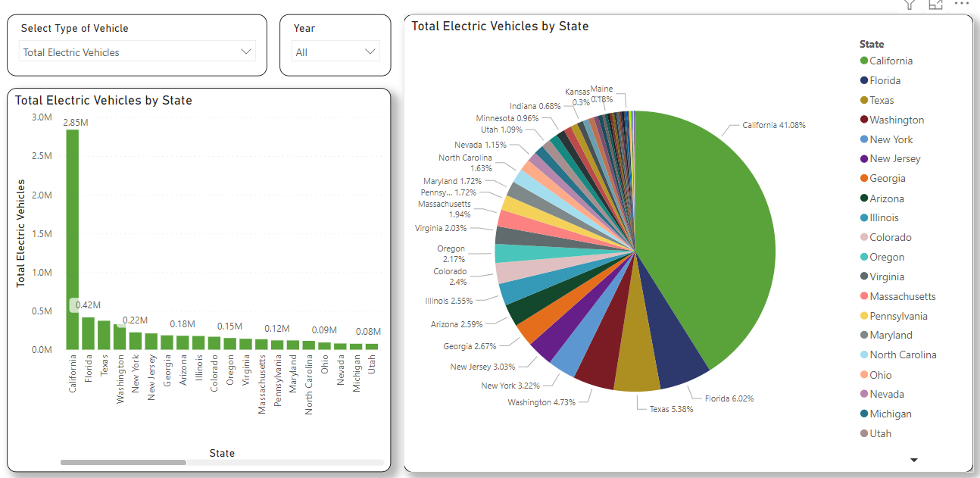

The above figure shows the sales of Electric Vehicles from 2016 to 2022 across all the states in USA. It has been observed that top 3 share is of California with 41.08% (2.85 million), Florida with 6.02%(0.42 million) & Texas with 5.38% (0.3 million).

* In the sales biodiesel vehicles Texas, California, Florida occupies the top 3 positions with 16.89%, 7.36%, 5.94% respectively.
* In the sales of Hybrid Electric Vehicles California had the highest with 8344100 26,643.91% higher than North Dakota, which had the lowest Total Hybrid Electric Vehicles at 3120. Texas & Florida occupies in the 2nd & 3rd positions with 5.37% & 5.32%.

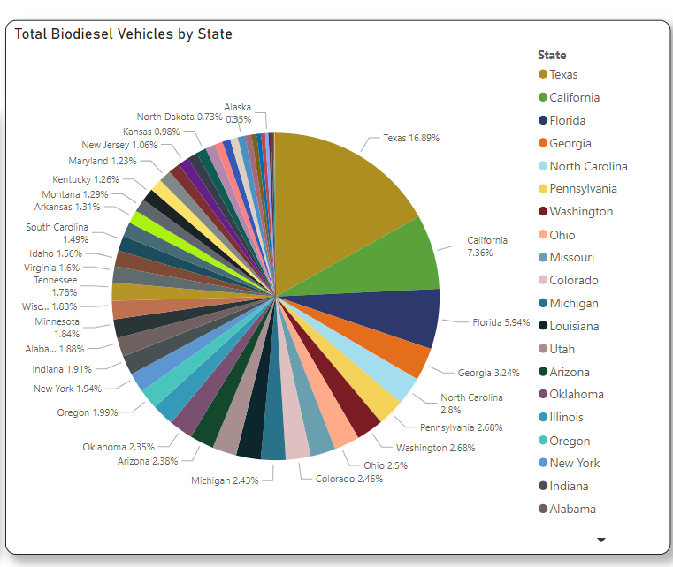

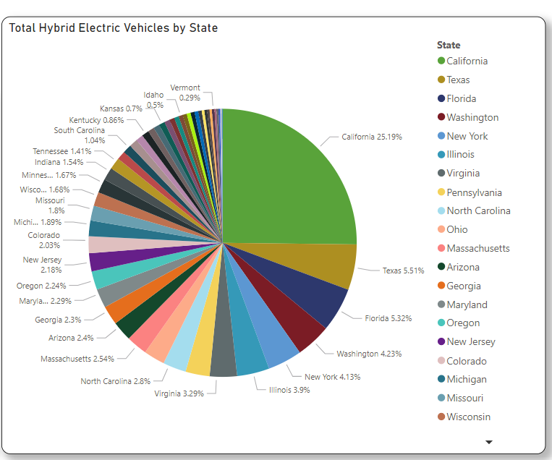

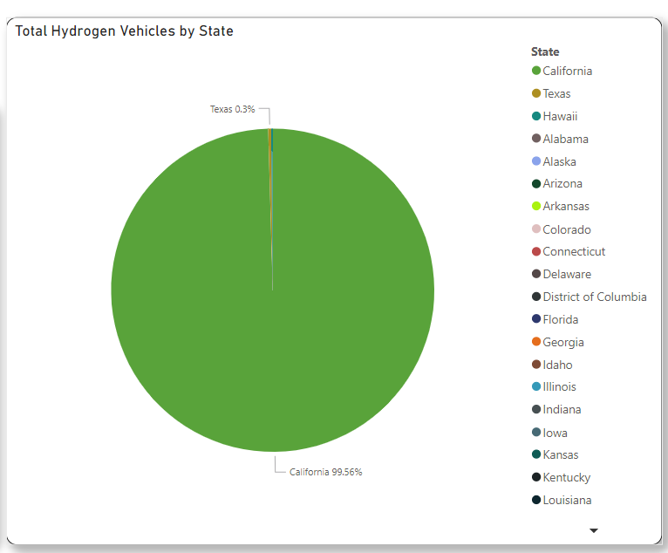

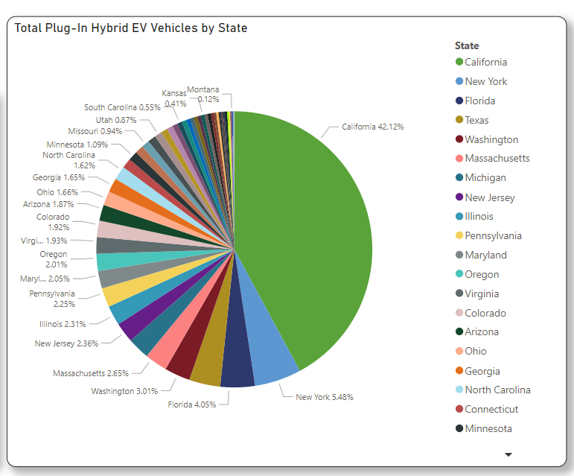

* Total Hydrogen Vehicle sales was highest for California at 67300, followed by Texas and Hawaii.﻿﻿ ﻿﻿ ﻿﻿California accounted for 99.56% of Total Hydrogen Vehicles.﻿﻿ ﻿﻿ ﻿﻿Across all 51 State.
* California had the highest Total Plug-In Hybrid EV Vehicles with 1680500 and was 88,347.37% higher than Wyoming, which had the lowest Total Plug-In Hybrid EV Vehicles at 1900. California accounted for 42.12% of Total Plug-In Hybrid EV Vehicle. New York, Florida, Texas comes after California.

**4) Scatter Plot:**

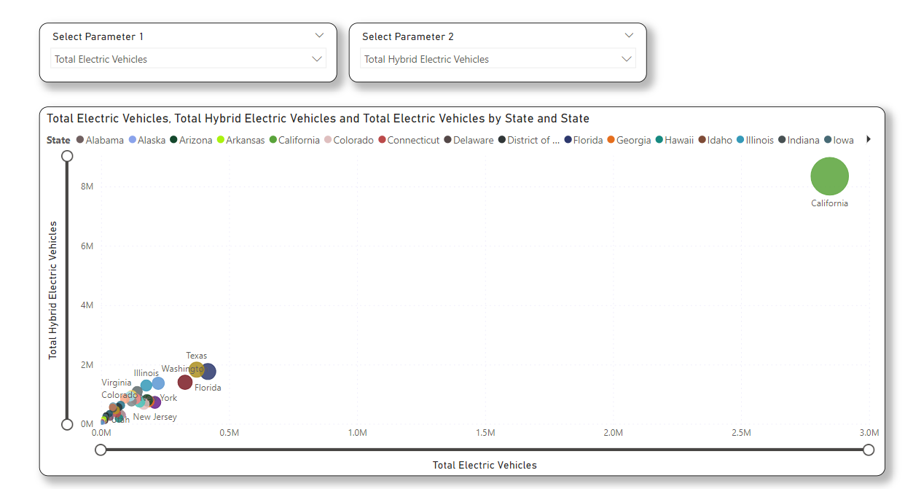

* California, Florida, Texas are leading with highest number of Electric Vehicles, Hybrid electric vehicles, Plug in Hybrid Electric Vehicles.
* Texas has highest number of Flex Vehicles beating california.
* California, has highest number of Gasoline & Electric Vehicles followed by Texas & Florida

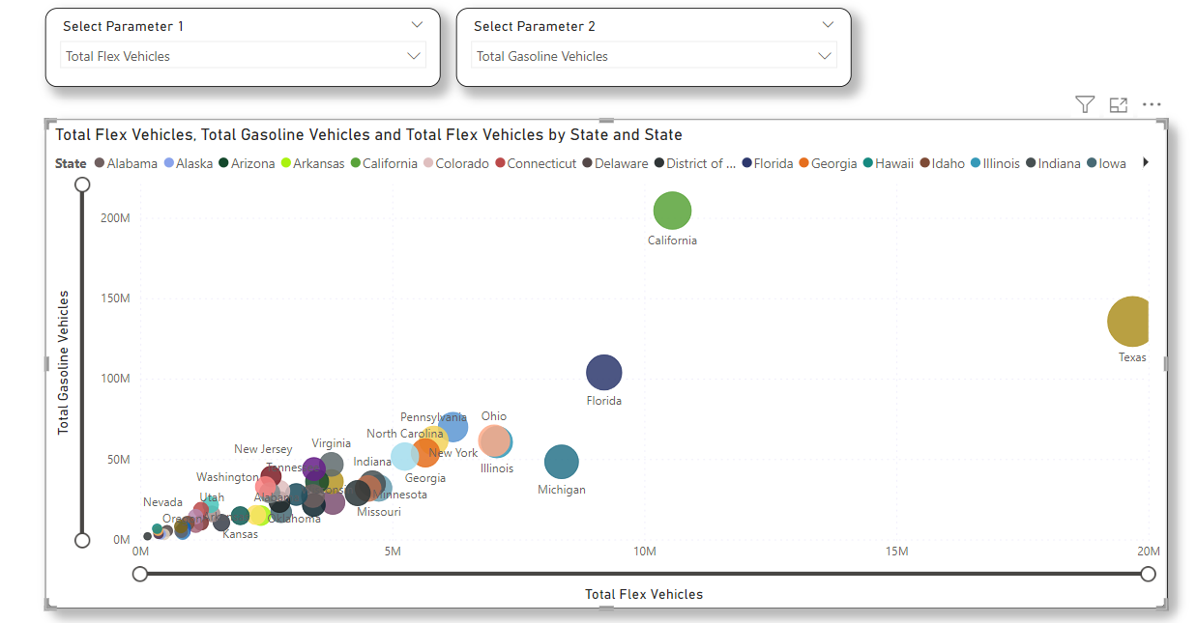

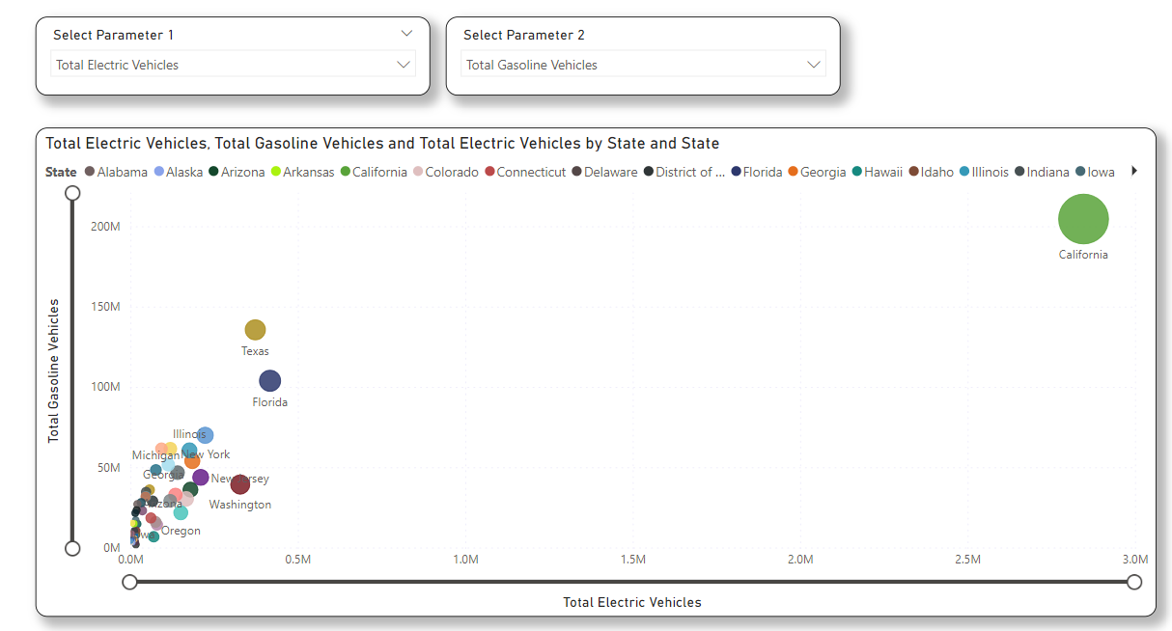

**5) EV Models by Manufacturer:**

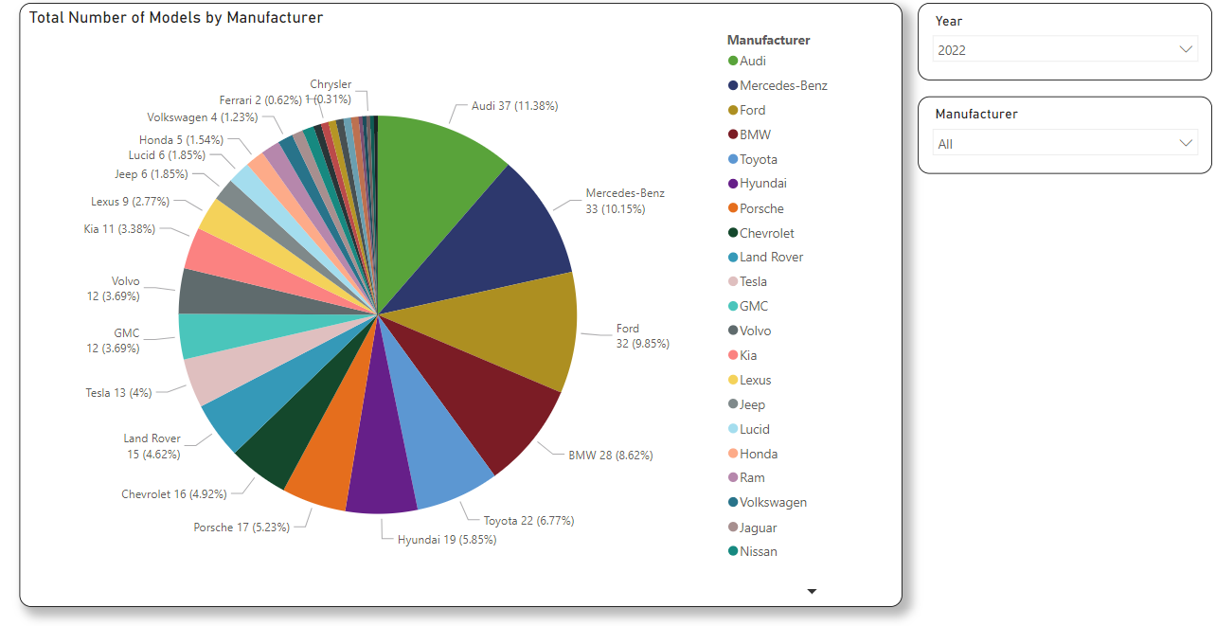

* ﻿Total Number of Models was highest for Audi at 37, followed by Mercedes-Benz and Ford. ﻿﻿Audi accounted for 11.38% of Total Number of Models where as Tesla accounted to 4% which is 13 models.
* In the year 2021 Ford accounted to 12.64% of the EV models.

**6) Laws & Incentives:**

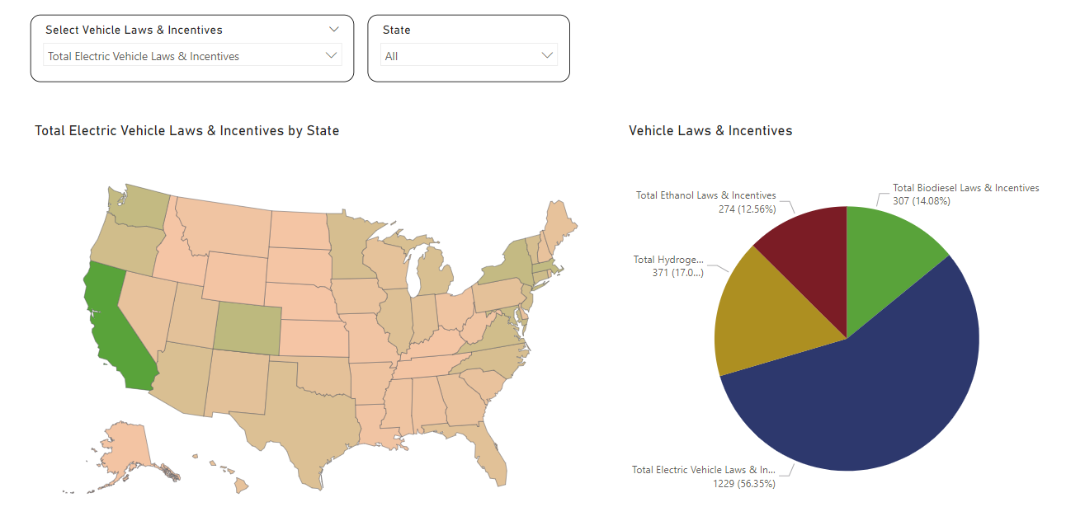

* From the above picture we can observe that California has highest number of Electric Vehicle Laws & Incentives followed by Colorado & Massachusetts. This proves that there is high correlation between number of electric vehicle laws & sales of electric vehicles, hence California leads in sales of electric vehicles.

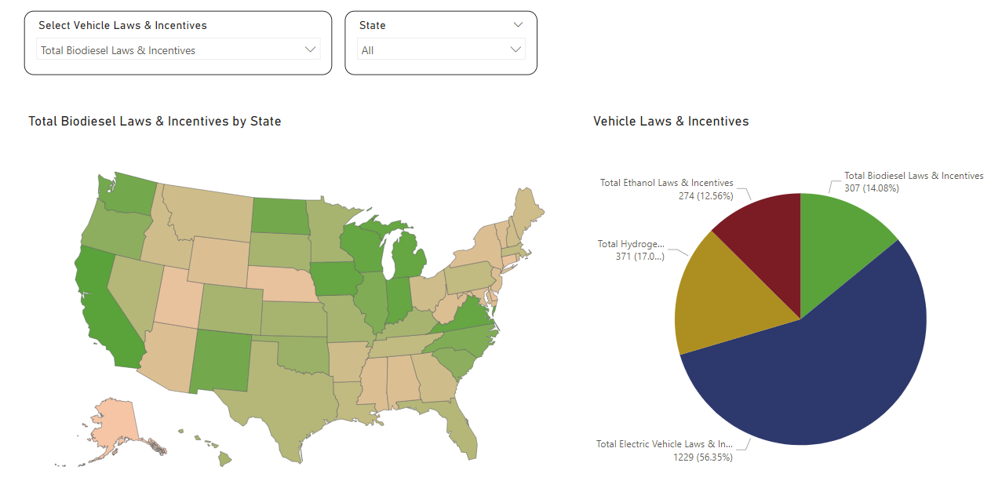

* From the above picture we can observe that California with 13 has highest number of Biodiesel laws Vehicle Laws & Incentives followed by Indiana, Iowa, Michigan, Virginia, Wisconsin at 12. High correlation between laws & sales of biodiesel vehicles.

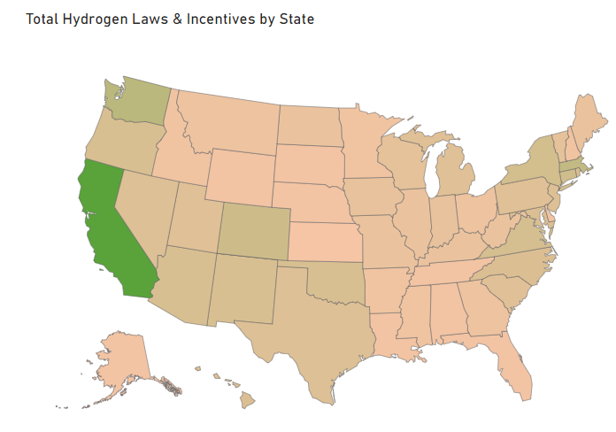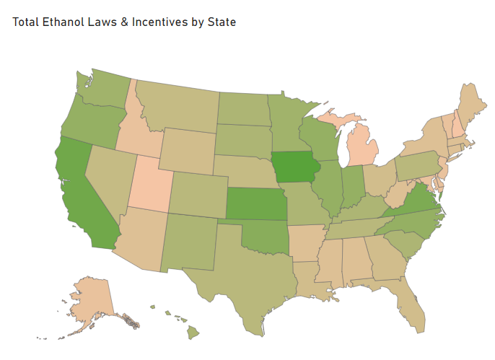

* From the above picture we can observe that Iowa has highest number of Ethanol Laws with 14 followed by California & Kansas of 12.
* From the above picture we can observe that California has highest number of Hydrogen Laws followed by Washington, Massachusetts. High correlation between laws & sales of Hydrogen vehicles.

**6) Map - KPIs**

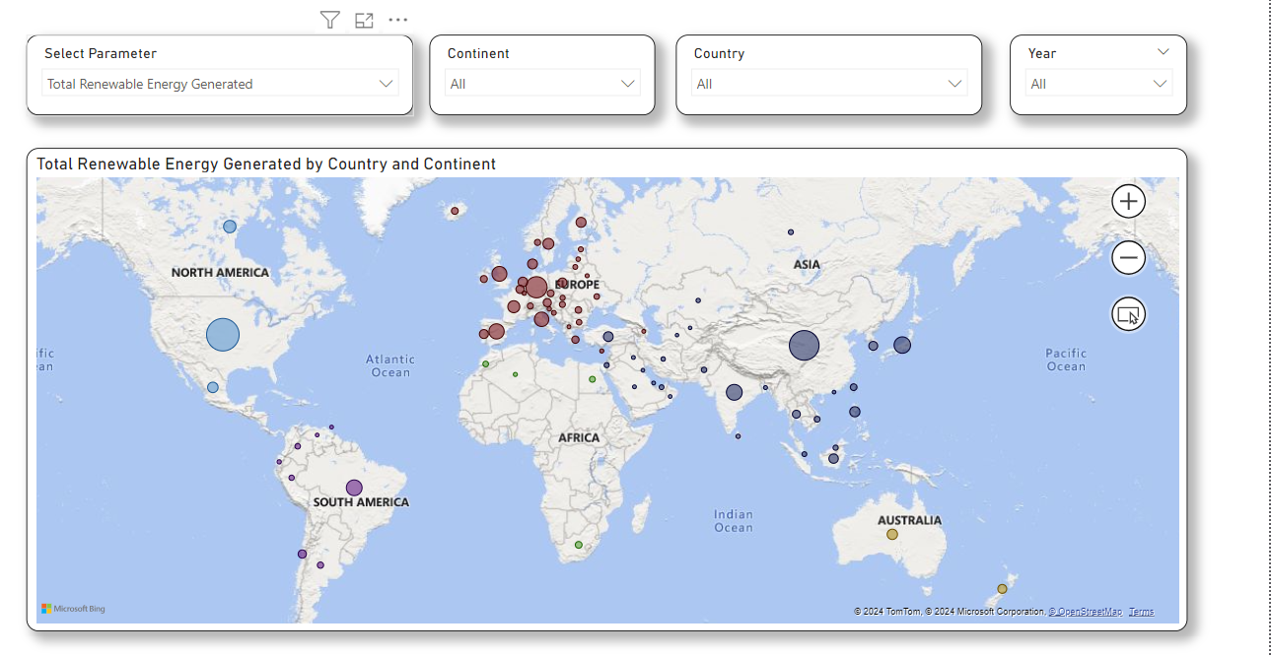

* The above map has the data from 1960-2021 & in the year 2021 China leads with total renewable energy generation with 32.01% which is 1152.53 TWh followed by USA with 624.45 TWh.
* In the year 2021 China generates 327 TWh from Solar Energy followed by USA with 165.5 TWh.
* China leads in the Installed capacity of Photovoltaic Cells & Wind Turbines with 306402 MW & 328973 MW.
* The total CO2 Emissions from China are 10523 million MT followed by USA (4701 million MT) & India (2552 million MT).
* Russia is highest in the CO2 Emissions from Flaring in the year 2021 with 53.32 million MT

**7) Animated Bar Chart:**

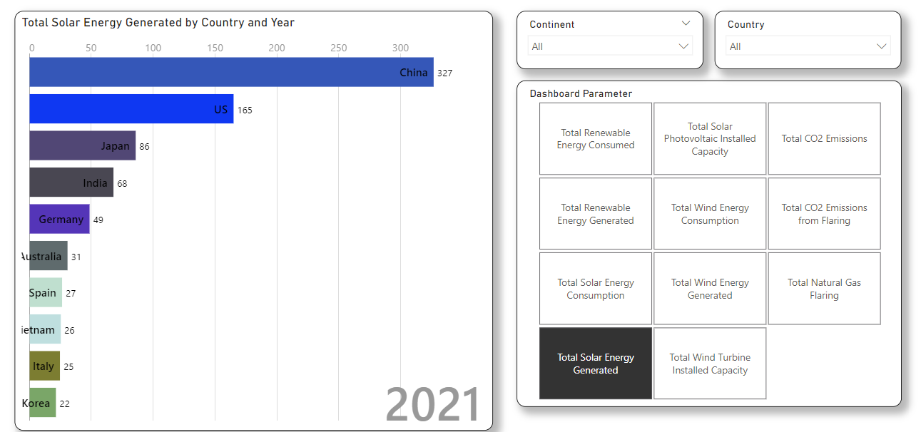

From the above Animated bar chart, we can see the transformation & growth in all the countries by continent wise. From the above chart we can observe that China & US leads in Solar Energy Generation. If we select the parameter total renewable energy generated again it’s China & US.

**8) Line Chart:**

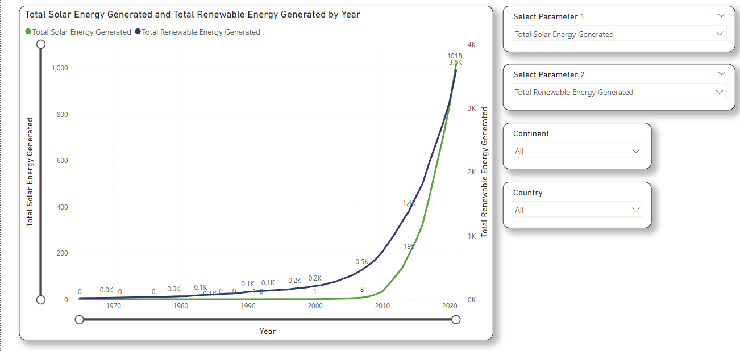

The above chart shows Solar Energy Generation & Renewable Energy Generation with Continent & Country filters. There is an exponential increase in the generation of renewable energy sources.

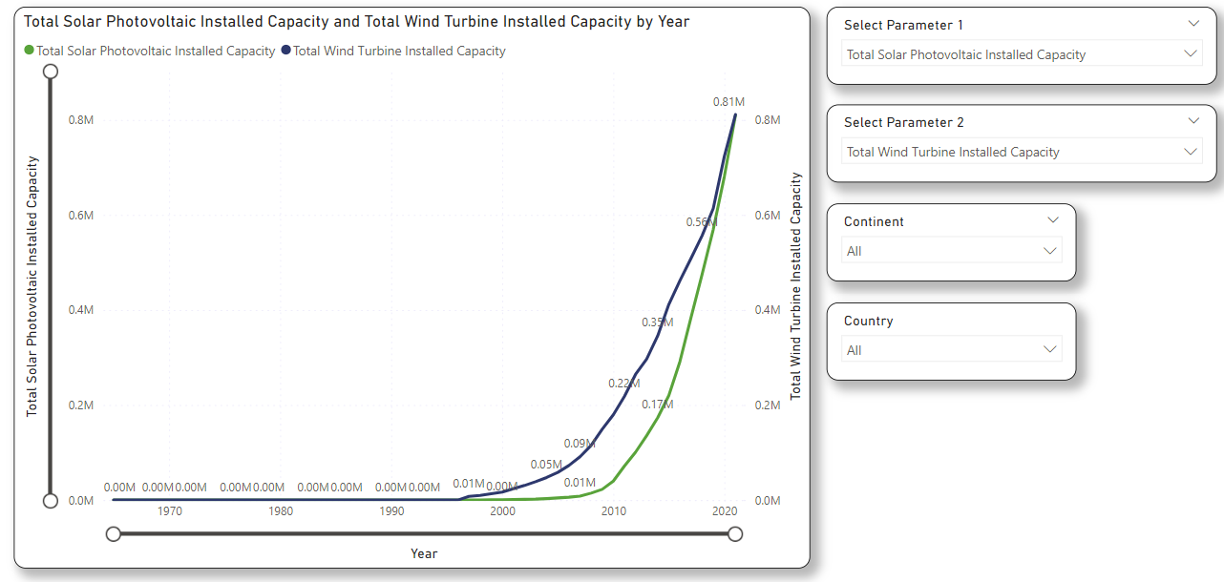

The above chart shows the installed capacity of Solar Photovoltaic Cells & Wind Turbines. There is an exponential increase from the year 2006.

**9) Pie Chart:**

The below chart shows the Solar Energy Consumption continent wise for all the years from 1960 to 2021. Asia & Europe leads across all the continents.

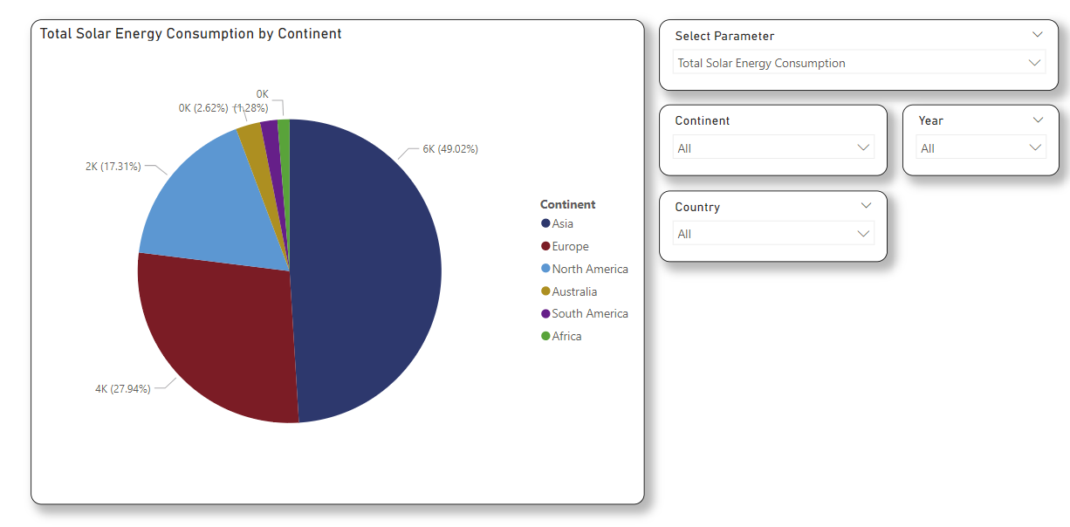

The below chart shows the Solar Energy Generation country wise for all the years from 1960 to 2021. China, USA, Japan, India leads across all the countries.

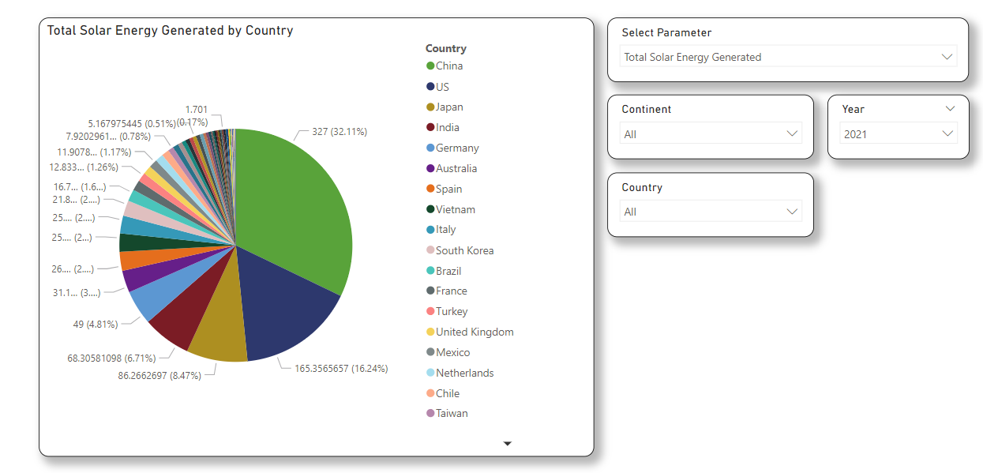

﻿**10) Forecast 1:**

The below graph shows the forecast of Renewable Energy Generation across all the continents. Forecast length is 10 points & with 95% confidence interval.

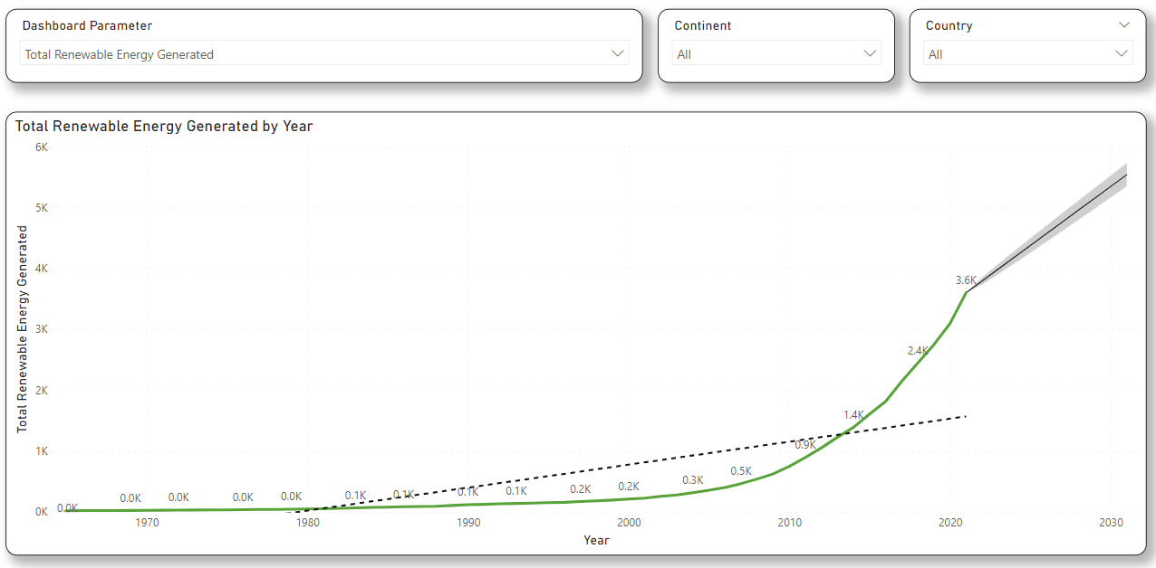

The below graph shows the CO2 Emissions for all the continents & the emissions follows the trend line & there is a slight downward trend in the year 2019 due to covid 19 pandemic.

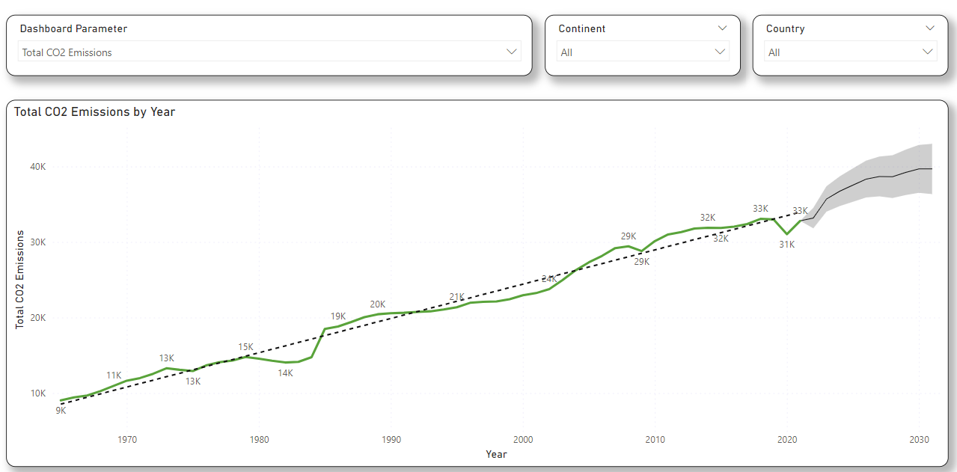

**11) Forecast 2:**

The below forecast shows the total electric vehicles in the USA for different states. The forecast is for 5 points & 90% confidence intervals. The forecast shows it breaks the trend line.

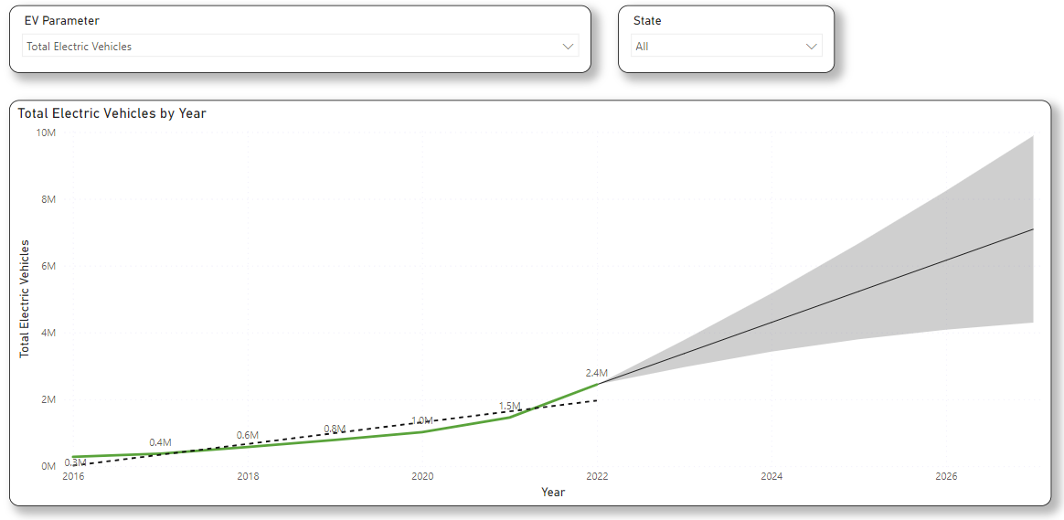

The below trend line shows the Hybrid Electric Vehicles for the state California. The forecast length is 5 points & with 90% confidence interval.

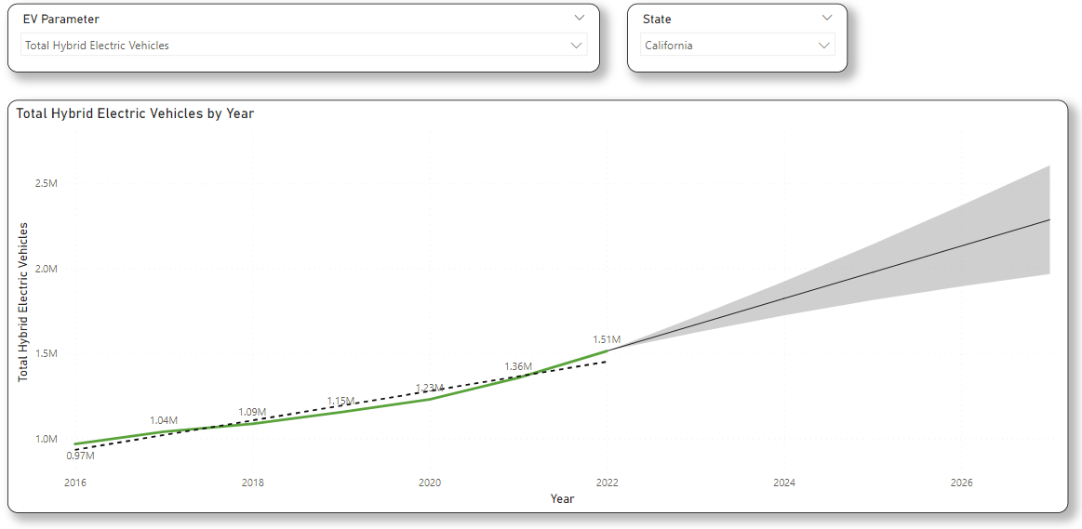

**12) Global Renewable Energy Dashboard:**

From the below scatter chart, we can select two parameters & find the relation between them. The animation of this scatter chart makes end users captivated. The below dashboard shows the details of all the renewable energy parameters with respect to continent, Country & Year. Waterfall Chart, Line Chart, Pie Chart shows the details of continent wise & year wise respectively. In the year 2021 the total renewable energy generated is of 3.6 TWh with Asia on top. The most recent Total Renewable Energy Generated was in 2021, when North America had a high of 714.14. Total Renewable Energy Generated for South America started trending up on 2011, rising by 349.22% (153.02) in 10 years. Asia accounted for 33.20% of Total Renewable Energy Generated. In the year 2019 there is slight downward trend of CO2 Emissions due to rise of alternative energy sources & electric vehicles, affect of covid 19 pandemic. Hence it is a combined affect which proves that CO2 emissions has been slightly decreased

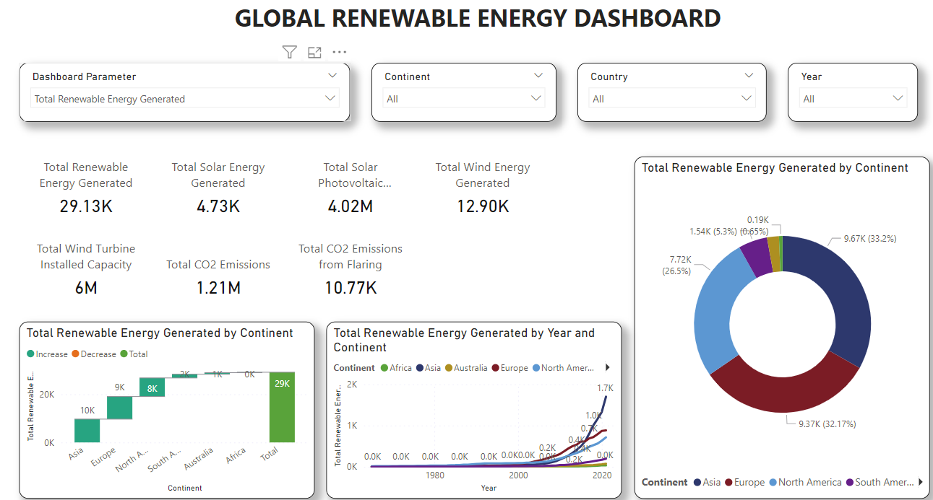

**13) EV Dashboard:**

The below dashboard is of USA Electric Vehicle Dashboard which shows number of EV Models by Manufacturer, Total Electric Vehicles with CO2 Emissions & State wise number of fuel stations.

﻿Total Electric Vehicles trended up (771.32% increase) while Total USA CO2 Emissions (5.18% decrease) trended down between 2016 and 2022.﻿﻿ Total USA CO2 Emissions started trending down on 2019, falling by 4.82% (248.50) in 2 years. Total Electric Vehicles jumped from 572600 to 2442300 during its steepest incline between 2018 and 2022.The most recent Total Number of Models anomaly was in 2022, when Mercedes-Benz had a high of 33. Total Number of Models for Mercedes-Benz started trending up on 2017, rising by 371.43% (26) in 5 years.

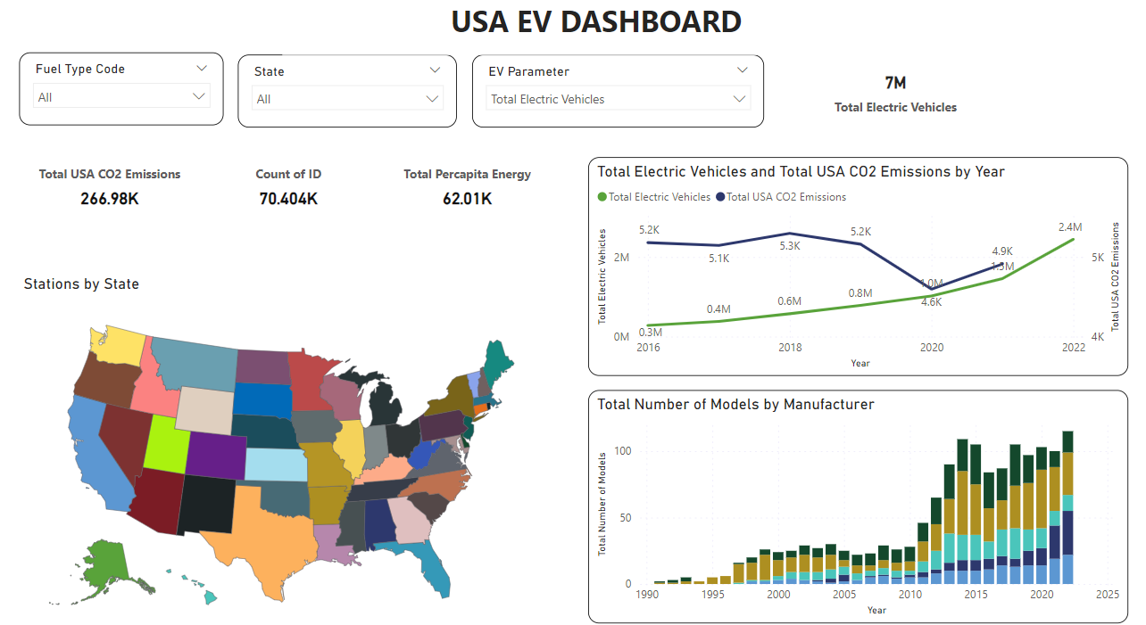

**Conclusion:**

**Question 1:**

* From Analysis 1 we can observe that California has 25.27% of total EV charging stations which is 15789 in USA.
* From Analysis 1 we get the details of Hydrogen Stations where California leads with 98.21% with 55
* From Analysis 1 Minnesota highest E85/Ethanol fuel stations of 9.48% with 408

**Question 2:**

* From the analysis 2 we can find that in the year 2022 Gasoline Vehicles leads the market with 241 million which is 85.67%
* The share of Electric Vehicles in 2022 is 0.87% with 2.44 million

**Question 3:**

* From the analysis 2 we can get the initial & latest EV sales from 2016 to 2022, the percentage increase in sales of EV is 771.43% with a CAGR of 61.15% during 2016-2022.

**Question 4:**

* From the analysis 3 it has been observed that California has highest number of Electric Vehicles, Hybrid Electric Vehicles, Plug-in Hybrid Electric Vehicles.

**Question 5:**

* From the analysis 4 by selecting the parameters Total Electric Vehicles & Total USA CO2 Emissions we observe that California has a greater number of Electric Vehicles & less in terms of CO2 Emissions. Texas is the state with more CO2 Emissions & less in number of Electric Vehicles.

**Question 6:**

* In the year 2022 there are 325 EV models are available in USA with Audi leading with 37 models (11.38%) & Tesla has 13 models (4%).

**Question 7:**

* From the analysis 6 we can observe that there are 137 Electric Laws/Incentives & 59 Hydrogen Laws/Incentives in California
* From the analysis 6 we can observe that in Biodiesel California has 13 & In Ethanol Iowa has 14 Laws/Incentives

**Question 8:**

* From the Analysis 7 we can the total CO2 Emissions of USA are 4701.1 million MT.